Ideation Phase
Empathize & Discover

Date | 7 July 2026
Team ID | SWTID-2026-2247
Project Name | Emotion Detection and Learning Support Engine
Maximum Marks | 4 Marks

Empathy Map Canvas:
An empathy map is used here to capture what a target user of the Emotion Detection and Learning Support Engine says, thinks, does, and feels while dealing with difficult emotions.

It helps the team move beyond assumptions and design an emotion detection experience grounded in how real users actually behave and feel.
Creating an effective solution requires understanding the true problem and the person who is experiencing it. For this project, the exercise helps the team consider the emotional journey of a user seeking guidance, along with their goals, frustrations, and unmet needs.
How This Shapes the Product:
Insights from this empathy map directly inform the keyword-enhanced preprocessing, the tone of the AI-generated guidance, and the design of the Streamlit interface, ensuring the system responds the way a real user would want to be heard.
Example:
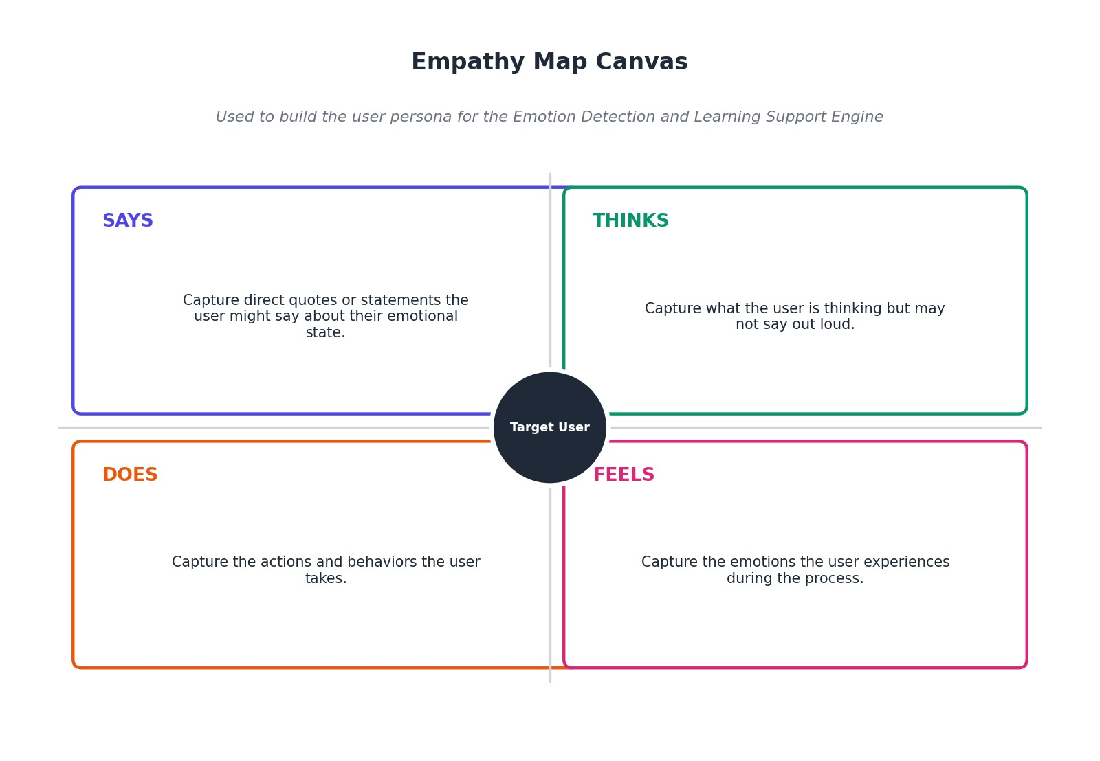

Example: Food Ordering & Delivery Application
